**Ideation Phase**

**Define the Problem Statements**

|  |  |
| --- | --- |
| Date | 18 October 2022 |
| Team ID | PNT2022TMID24177 |
| Project Name | IoT Based Safety Gadget for Child Safety Monitoring and Notification |
| Total number of members | 4 |
| Team leader name | BANDARU VINAY KUMAR |
| Team member 1 | A AYYAPPA SHARMA |
| Team member 2 | GUMMADI VENKATA SIVA PRASAD |
| Team member 3 | BANDI THEJESH |
| Mentor Name | PADMANABAN |

**Customer Problem Statement Template:**

|  |  |  |
| --- | --- | --- |
| **I am** | **Describe customer with 3-4 key characteristics -who are they child (0-5) yrs** | **Customer are parents who having child and willing to take care of their child** |
| **I’m trying to** | **List their outcome or “job” the care about what are they trying to achieve** | **The parents are trying to achieve their child in safer side.** |
| **But** | **Describe what problems or barriers stand in the way – what bothers them most** | **The parents can’t able to spend more time with the child Inspite of their work.They can’t able to safe their child to overcome this situation parents from their workplace itself can monitor their child** |
| **Because** | **Enter the “root cause” of why the problem or barrier exist what needs to be**  **solved** | **Ultrasonic sensor is fixed to the device with the child when any object exist near child using pieze buzzer alarm established and SMS & Mail will automatically hit the parents Mobile .SMS and Mail again and again**  **Noticing is quite difficult**    **The needs to solve: Everyone give more importance to call rather than SMS and mail.Hence**  **using dialing/ calling method is used to overcome this problem** |
| **Which makes me feel** | **Describe the emotions from the customer ‘s point of** | **It reduce the customer stress and feels them relax** |
|  | **view – how Does it impact them emotionally** |  |

Reference: https://miro.com/app/board/uXjVPSqvoTk=/ **Example:**

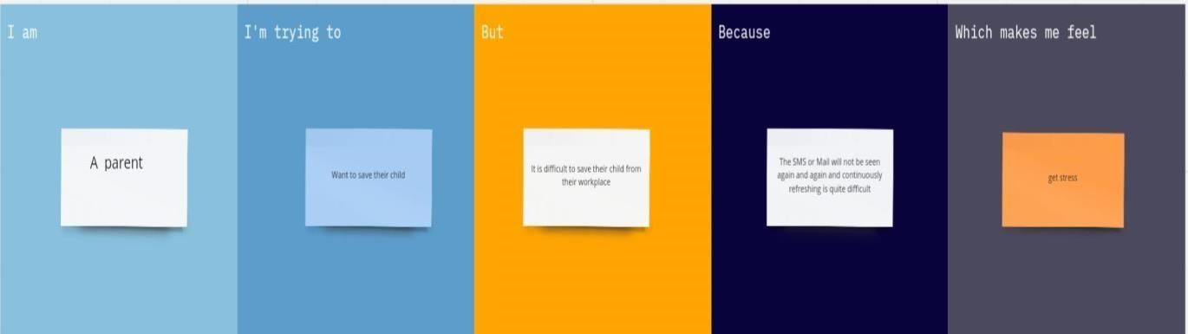

|  |  |  |  |  |  |
| --- | --- | --- | --- | --- | --- |
| **Problem**  **Statement (PS)** | **I am**  **(Customer)** | **I’m trying to** | **But** | **Because** | **Which makes me feel** |
| PS-1 | A parent | Want to save  their child | It is difficult to save their child from their workplace | The SMS or Mail will not be seen again and again | Get stress |
| PS-2 | A parent | Want to save  their child | It is difficult to save their child from various place | The alarm buzzer will  may disturb the child | Disturb the child |
| PS-3 | A parent | Want to save  their child | It is difficult to save their child | Wi-fi and Bluetooth  are used | It may in certain range |